  Fortune Institute of International Business |   Aditya Birla Capital

AI-Powered Investment Risk &
Opportunity Dashboard
━━━━━━━━━━━━━━━━━━━━━━━━━━━━━━━
AI Solution Design and Build Bundle
Stage 2

Corporate Internship Program (CIP)

SUBMITTED BY

Anjali Gupta
PGDM – Financial Management
Batch 2024–26 | FIIB, New Delhi
Supervisor: Mr. Nikesh Ruparel (EAP)
Faculty mentor- Dr. Purnima Rao

Section 1: Problem Identification

1.1 Problem Statement
During the internship at Aditya Birla Sun Life Insurance (ABSLI), it was observed that investment-related analysis requires reviewing information from multiple sources such as annual reports, earnings call summaries, market news, corporate actions, sector updates, and technical indicators. Analysts often spend significant time collecting, reviewing, and interpreting information from different platforms before arriving at an investment assessment.
As the volume of financial information increases, there is a risk of delayed identification of important risk signals or investment opportunities. The problem primarily affects analysts and research professionals who need to process large amounts of financial information within limited timeframes.

1.2 Current Non-AI Process
The present process includes the following manual steps:

Table 1: Current Non-AI Process
S.No. | Activity | Limitation
1 | Reviewing annual reports and company disclosures manually | Time-consuming; prone to oversight
2 | Reading earnings call summaries and management commentary | Unstructured, scattered across sources
3 | Tracking market news from multiple platforms | Information overload; inconsistent format
4 | Monitoring corporate actions (dividends, splits, bonuses) | Manual tracking causes delays
5 | Analyzing technical indicators (RSI, MACD, EMA, Supertrend) | Requires switching between tools
6 | Combining observations before making an investment assessment | Fragmented process; insights may be missed

1.3 Why AI is Viable for This Problem
The identified problem is well-suited for AI integration because it is information-intensive, repetitive, dependent on large-volume data review, and suitable for pattern recognition. AI can consolidate information from multiple sources, identify trends and risk signals, reduce manual gathering effort, and generate structured insights for faster analysis.
Rather than replacing human decision-making, AI functions as a decision-support mechanism.

1.4 Problem Validation Timeline
The issue was validated through:
- Discussions with internship supervisor (Mr. Nikesh Ruparel)
- Observation of investment research activities during the internship
- Review of information sources used for market and company analysis
The problem gained relevance during internship activities related to: Equity Research, FMCG Sector Analysis, Technical Indicator Analysis, Corporate Actions Review, and Market News Monitoring.

Section 2: AI Solution Design & Build

2.1 What Was Built?
The proposed solution is an AI-Powered Investment Risk & Opportunity Dashboard designed to support investment research and analysis activities. The dashboard consolidates information from multiple financial sources and presents it in a structured, visual format.
Instead of manually collecting and comparing information from reports, news sources, and technical analysis tools, the dashboard provides a unified view of relevant insights — generating risk indicators, opportunity indicators, sentiment observations, and decision-support insights.

2.2 AI Solution Features

Feature | Description
Primary Platform | Claude AI – used for analysis, structured insight generation, and dashboard simulation
Input Processing | Processes both structured and unstructured financial inputs
Output Format | Consolidated dashboard with scores, risk flags, and recommendations
Decision Support | Supports analysts without replacing professional investment judgment
Prototype Stage | AI-assisted conceptual dashboard; not integrated with live systems

2.3 Input Sources

Input Source | Examples / Details
Annual Reports | Company disclosures, financials, management discussion
Earnings Call Highlights | Management commentary, guidance, Q&A summaries
Market News | Sector updates, macro news, analyst reports
Corporate Actions | Dividends, stock splits, bonus issues, rights issues
Technical Indicators | RSI, MACD, EMA, Supertrend, Volume Trends
FMCG Sector Trends | Sector-level performance data and peer comparisons

2.4 Dashboard Outputs

Output | Description
Risk Score | Indicates the level of investment risk based on available information
Opportunity Score | Highlights positive signals and potential growth opportunities
Sentiment Score | Reflects overall market and business sentiment from news and reports
Technical Strength Score | Represents strength of selected technical indicators
Key Risks | Summary of significant risk factors identified during analysis
Key Opportunities | Summary of positive signals and investment catalysts
Corporate Action Assessment | Insights on dividends, splits, and other corporate events
Decision-Support Recommendation | Consolidated view to support investment analysis

2.5 Benefits and Limitations

Table 5: Benefits vs. Limitations
Benefits | Limitations
Consolidates multiple data sources into one interface | Prototype only – not integrated with live systems
Reduces manual effort and research time | Output quality depends on input completeness
Provides structured risk and opportunity indicators | Real-time market data integration not implemented
Supports faster investment analysis decisions | Wider deployment requires testing and approvals
Scalable to portfolio-level monitoring in future | Cannot replace professional investment judgment

Section 3: Diagrams & Process Flows

3.1 Data Flow Diagram
Annual Reports
▼
Earnings Calls
▼
Market News
▼
Corporate Actions
▼
Technical Indicators
▼
AI Engine (Claude AI)
▼
Risk & Opportunity Dashboard

3.2 Input → AI Processing → Output Flow
INPUTS | AI ENGINE | OUTPUTS
• Annual Reports  • Earnings Calls  • Market News  • Corporate Actions  • Technical Indicators  • FMCG Sector Trends | Claude AI  Analyze &  Synthesize | • Risk Score  • Opportunity Score  • Sentiment Score  • Technical Strength Score  • Key Risks & Opportunities  • Decision Recommendation

3.3 Dashboard Architecture

Layer 1: Data Input Layer
Annual Reports | Earnings Calls | Market News | Corporate Actions | Technical Indicators
▼
Layer 2: AI Processing Layer
Claude AI Engine | Pattern Recognition | Sentiment Analysis | Risk Scoring
▼
Layer 3: Output / Dashboard Layer
Risk Score | Opportunity Score | Sentiment Score | Decision Recommendation

3.4 Deployment Journey

1  Problem  Identified | 2  Prototype  Designed | 3  AI Engine  Configured | 4  Dashboard  Built | 5  Supervisor  Demonstration | 6  Level 1  Deployed

Section 4: Deployment Details

4.1 Deployment Level Achieved

Deployment Level | Level 1 – Prototype Demonstration
Demonstration Type | One-to-One at Workplace
Reviewer | Mr. Nikesh Ruparel (EAP / Internship Supervisor)
Location | Aditya Birla Sun Life Insurance, Workplace
Outcome | Solution reviewed and feedback provided
Reason for Level 1 | Not independently used by multiple employees; not integrated into regular operations

4.2 How the Solution Was Demonstrated
The solution was demonstrated to the internship supervisor during a one-to-one discussion at the workplace. A prototype workflow of the AI-Powered Investment Risk & Opportunity Dashboard was presented using sample FMCG company information.
The demonstration included use of annual report highlights, earnings call insights, market news, corporate actions, technical indicators, and sector-related information. The supervisor was shown how AI can process multiple information sources and present results through a consolidated dashboard.

4.3 Reviewer Observations
The internship supervisor reviewed the proposed dashboard structure, input sources, analytical outputs, and overall workflow. Feedback was provided regarding the usefulness of integrating multiple information sources into a single visual platform.

4.4 Supervisor Feedback

“The concept is useful, but analysts should not have to switch between multiple tools. A single integrated dashboard that combines reports, news, indicators, and corporate actions would be more practical and easier to use for investment analysis.”

— Mr. Nikesh Ruparel, EAP

4.5 Interest in Continued Use
The supervisor expressed interest in the concept and indicated that a more advanced version of the dashboard could be useful for research and analysis activities. Particular interest was shown in combining multiple information sources through a single visual interface.

4.6 Future Improvements

1 | Integration of live NSE/BSE market data | Real-time risk and opportunity detection
2 | Automated news and corporate action tracking | Eliminates manual monitoring effort
3 | AI-based annual report extraction and summarization | Faster processing of company disclosures
4 | Portfolio-level risk and opportunity monitoring | Broader organizational adoption
5 | Multi-company comparison dashboards | Improved peer analysis capability
6 | Enhanced visualization and reporting | Better communication of insights

Section 5: Evidence

The following evidence items were submitted to support the development and demonstration of the AI-Powered Investment Risk & Opportunity Dashboard. Each evidence item is presented on a separate page with a figure number and caption.

Evidence 1: AI Prompt Used

[ SC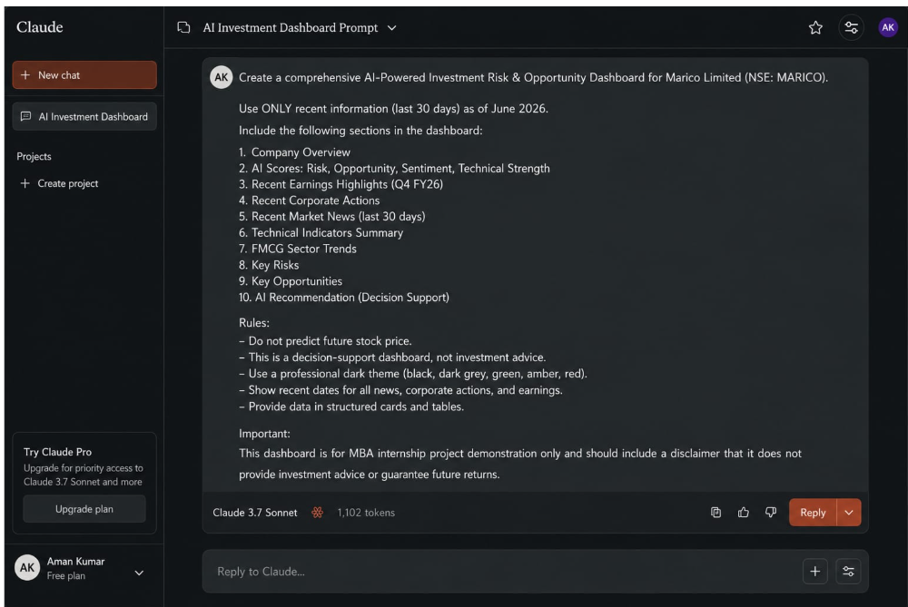REENSHOT PLACEHOLDER ]

Figure 5: Evidence 1 – AI Prompt Used

A prompt was created and used within Claude AI to simulate the functionality of the proposed AI-Powered Investment Risk & Opportunity Dashboard. The prompt instructed the AI system to analyze financial information from multiple sources (annual reports, earnings call highlights, market news, corporate actions, and technical indicators) and generate structured dashboard outputs including risk scores, opportunity indicators, and a decision-support recommendation.

Evidence 2: AI Analysis Output

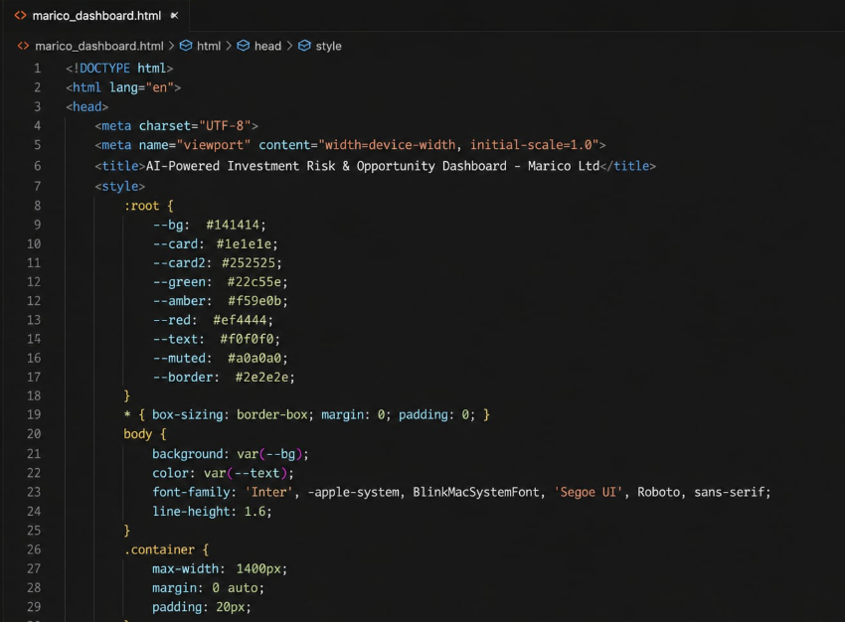

Figure 6: Evidence 2 – AI Analysis Output

The AI-generated output demonstrated how information from annual reports, market news, earnings highlights, corporate actions, and technical indicators could be consolidated into a single analytical framework. The output included Risk Score, Opportunity Score, Sentiment Score, Technical Strength Score, Key Risks, Key Opportunities, and a Decision-Support Recommendation.

Evidence 3: HTML Dashboard Prototype

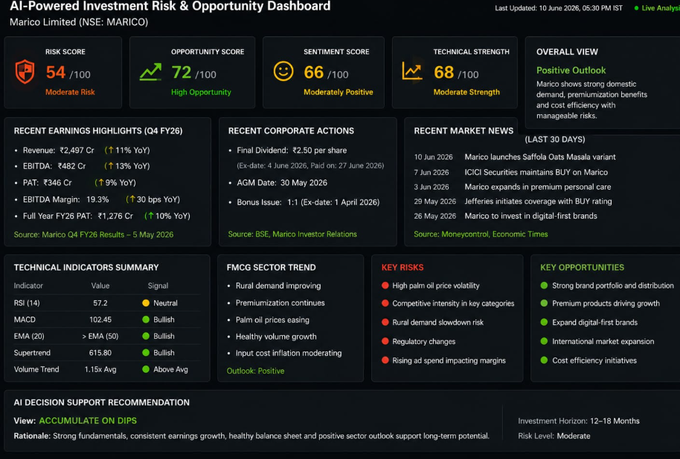

Figure 7: Evidence 3 – HTML Dashboard Prototype

A dashboard prototype was developed in HTML format to visually demonstrate how the proposed AI solution could present information to analysts through a single interface. The dashboard contained: Company Overview, Risk Indicators, Opportunity Indicators, Technical Analysis Summary, Market News Summary, Corporate Action Summary, and an AI Recommendation Panel.

Evidence 4: Demonstration Record

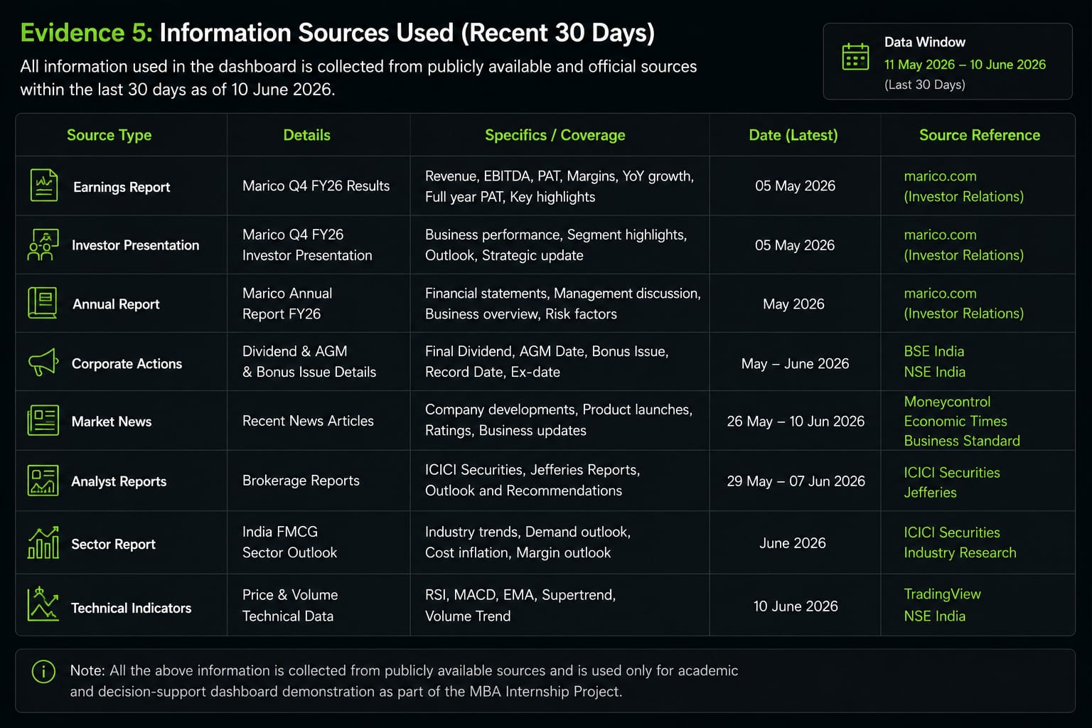

Figure 8: Evidence 4 – Demonstration Record

The dashboard workflow and outputs were demonstrated to the internship supervisor (Mr. Nikesh Ruparel) through a one-to-one discussion at the workplace. The demonstration included: explanation of the problem statement, dashboard workflow walkthrough, input sources overview, dashboard output review, and a practical use-case discussion.

Section 6: Final Reflection

The project provided practical exposure to identifying business problems suitable for AI intervention and designing a prototype solution aligned with organizational needs. Through discussions, demonstrations, and feedback from the supervisor, it was observed that AI can add significant value when applied to information-intensive and analysis-heavy processes such as investment research.

The project highlighted the importance of combining multiple information sources into a single decision-support platform to improve efficiency and support analytical decision-making. The experience demonstrated that even a prototype-level AI solution can generate meaningful insights when structured inputs are provided.

Key takeaways from the project include:
- Business problem identification requires careful observation and validation with domain experts
- AI solutions must be designed as decision-support tools, not as replacement for human judgment
- The value of AI increases proportionally with the volume and complexity of information to be processed
- Supervisor feedback is critical in refining and validating the scope of AI interventions
- Future enhancements should focus on real-time data integration and broader organizational adoption

Future enhancements may focus on real-time NSE/BSE data integration, automated information collection, AI-powered annual report summarization, and broader organizational deployment across research and analysis teams.

